**OUTPUT FOR REAL-TIME RIVER WATER QUALITY MONITORING AND CONTROL SYSTEM**

**OUTPUT**

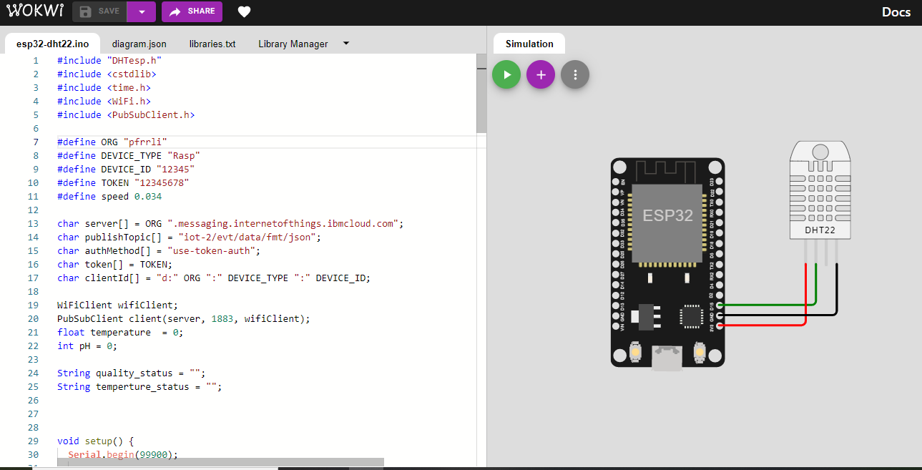

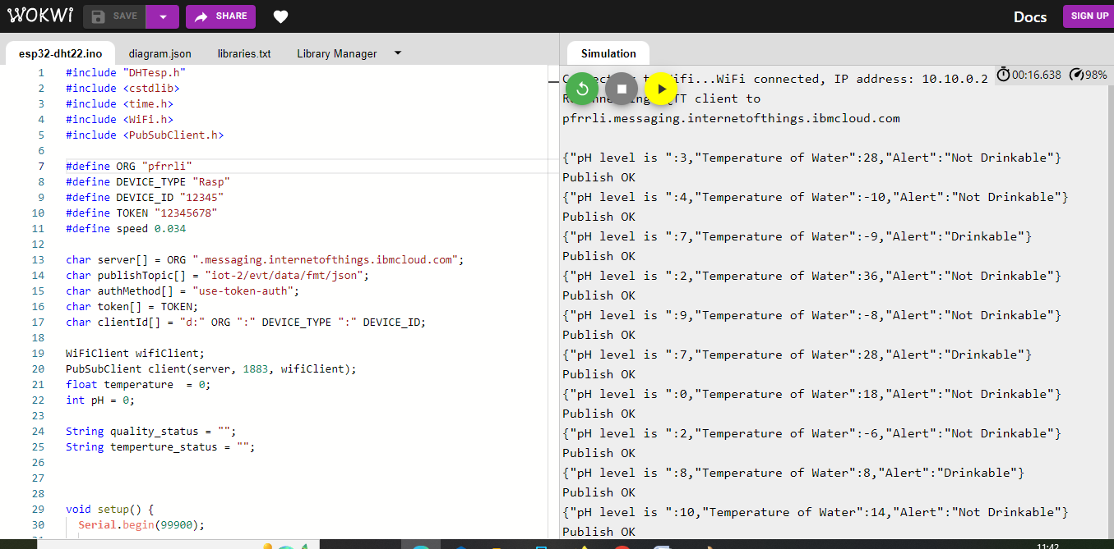

**WASTON IOT PLATFORM**

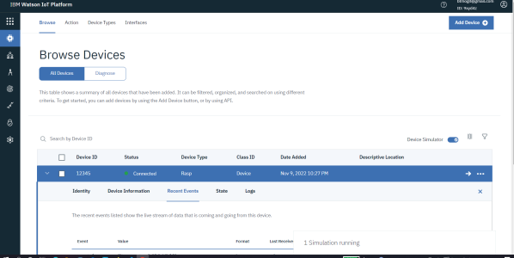

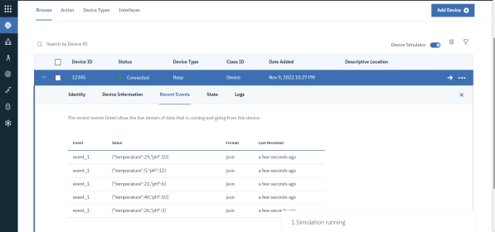

**NODE RED**

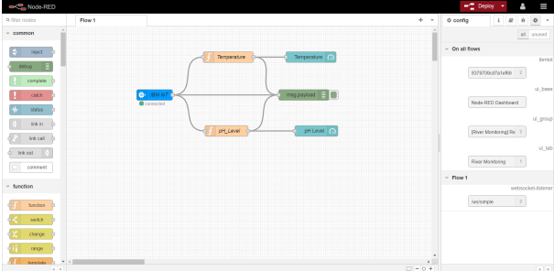

**WEB UI**

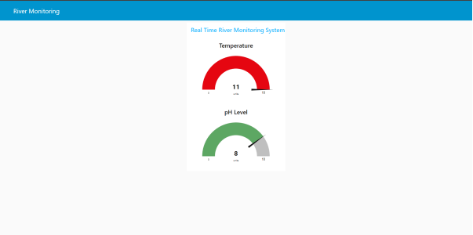

**DEMO LINK**

**https://tinyurl.com/ycxxyaj8**